**Practice Problem set 1**

You don’t have to turn it in. This is for practice purpose.

You are encouraged to practice and get familiar with the questions.

( John G. Proakis / Masoud Salehi, Volume V )

**Problem 3.2**

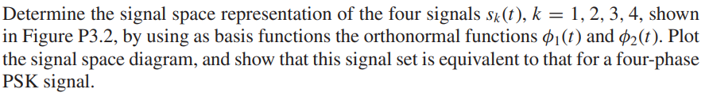

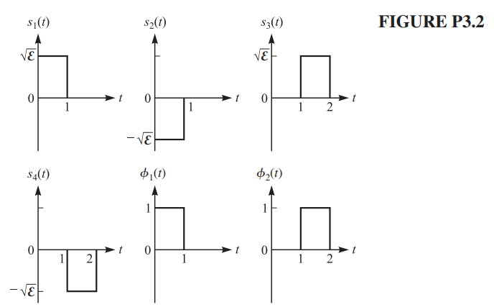

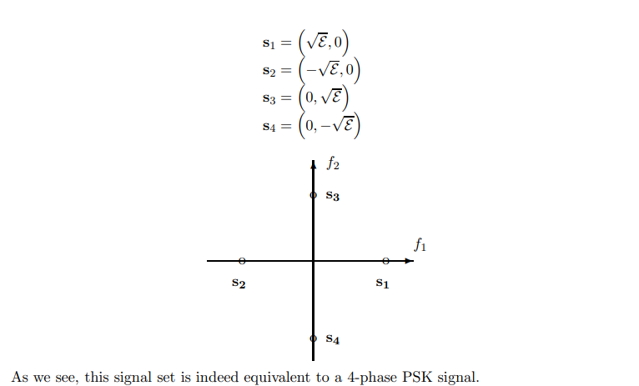**Solution:**

**Problem 3.3**

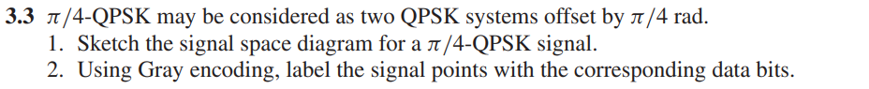

**Solution:**

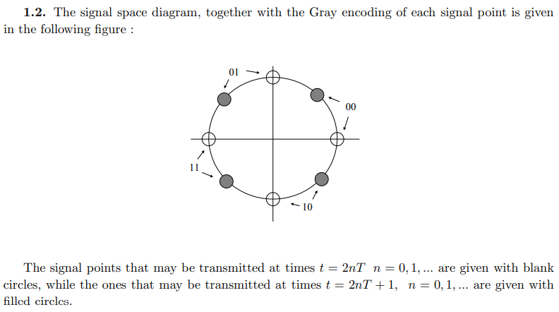

**Problem 3.4**

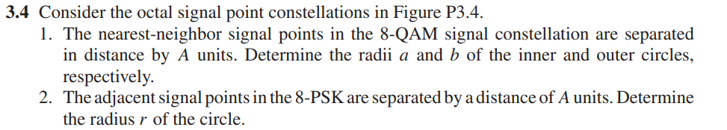

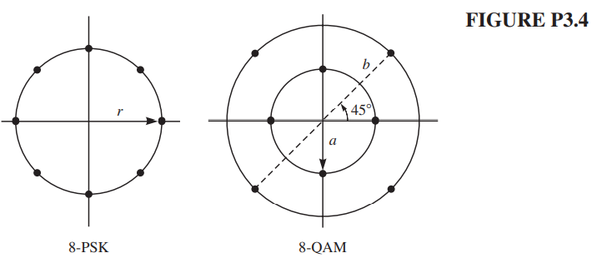

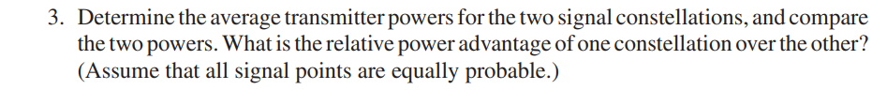

**Solution:**

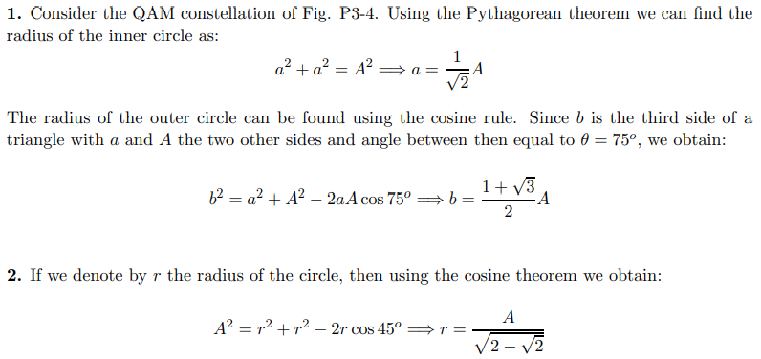

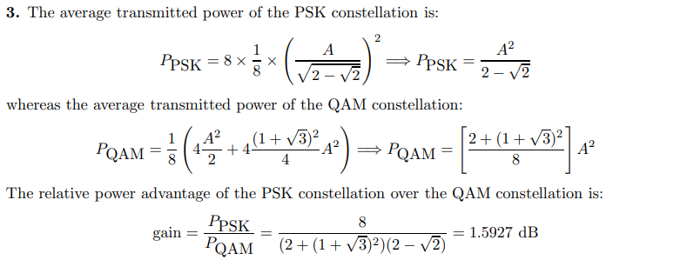

**Problem 3.5**

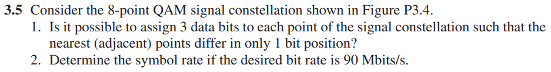

**Solution:**

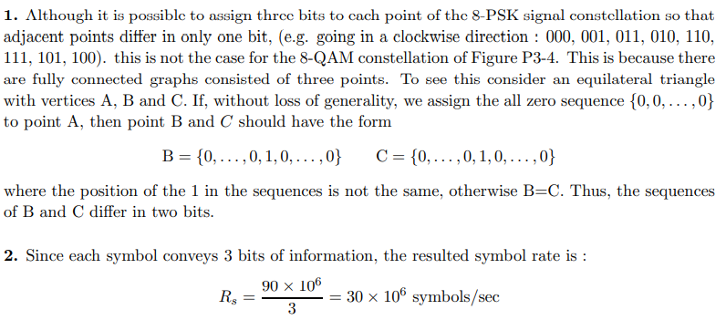

**Problem 3.6**

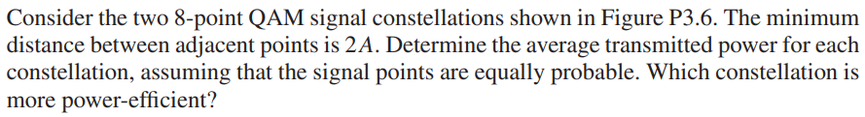

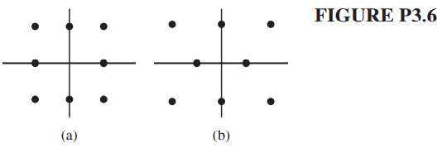

**Solution:**

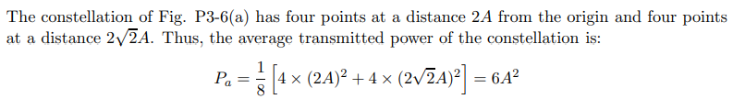

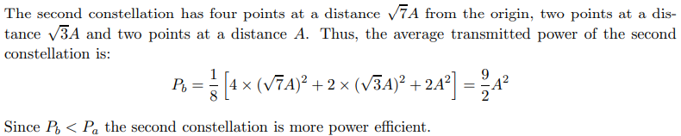

**Example 4.1-1 ( page 164 )**

**Problem 4.4**

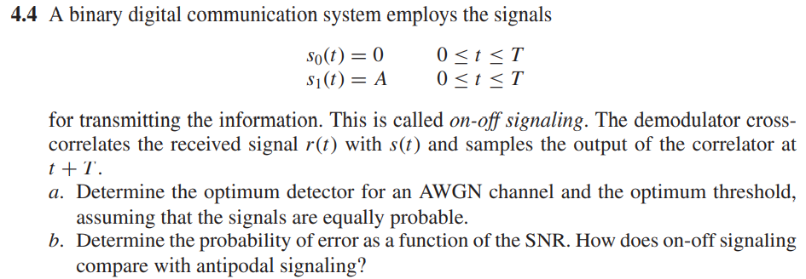

**Solution:**

